|  |  |
| --- | --- |
|  | Student Name _______________________    **Eastern Goldfields College**  Mathematics Applications U3&4 2019  Test 6 1– Calculator Free Section |
| **Working Time: 15 minutes** | **Total Marks: 15 marks** |

**Question 1 [6 marks: 3, 1, 2]**

The network below shows the distances, in kilometres, between nine towns, P, Q, R, S, T, U, V, W and X.

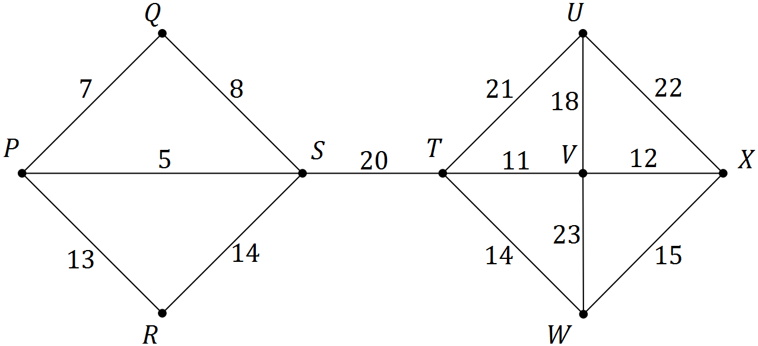

a) Use Prim’s algorithm, starting at P, to determine a minimum spanning tree for the network and draw the minimum spanning tree below.

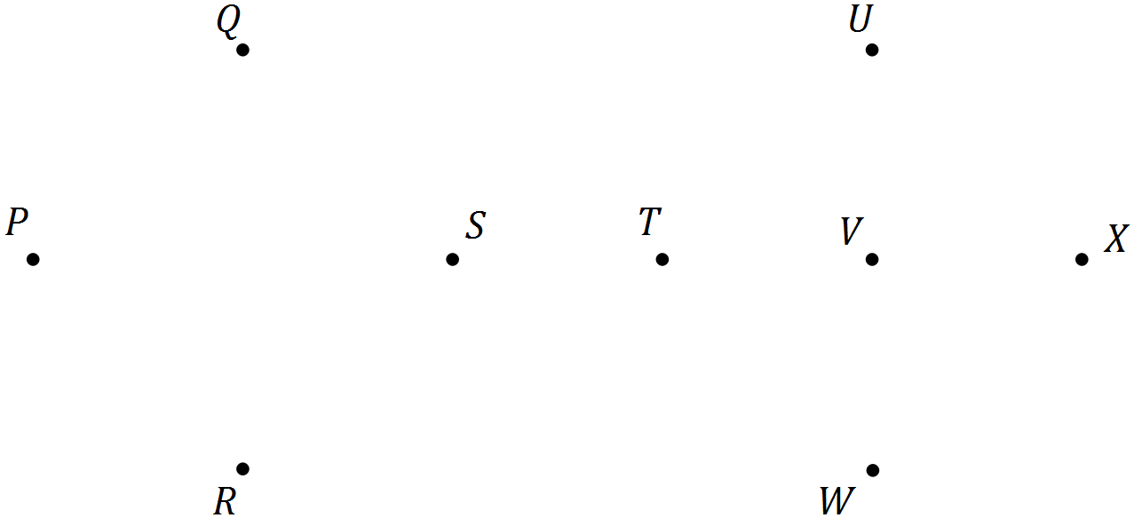

b) State the length of the minimum spanning tree.

c) Prim’s algorithm from different starting points produces the same minimum spanning tree for this network. State the final edge that would complete the minimum spanning tree using Prim’s algorithm:

i) starting from S ii) stating from W

**Question 2 [3 marks]**

The arc lengths between the five vertices A, B, C, D and E of a network are shown in the table below. Determine the length of the minimum spanning tree for this network.

|  |  |  |  |  |  |
| --- | --- | --- | --- | --- | --- |
|  | A | B | C | D | E |
| A | 0 | 13 | 15 | 14 | 12 |
| B | 13 | 0 | 12 | 14 | 11 |
| C | 15 | 12 | 0 | 13 | 13 |
| D | 14 | 14 | 13 | 0 | 14 |
| E | 12 | 11 | 13 | 14 | 0 |

**Question 3 [6 marks: 1, 4, 1]**

The following network diagram shows the **FLOW** in a system of pipes that achieves the maximum flow for the system, in litres per minute.

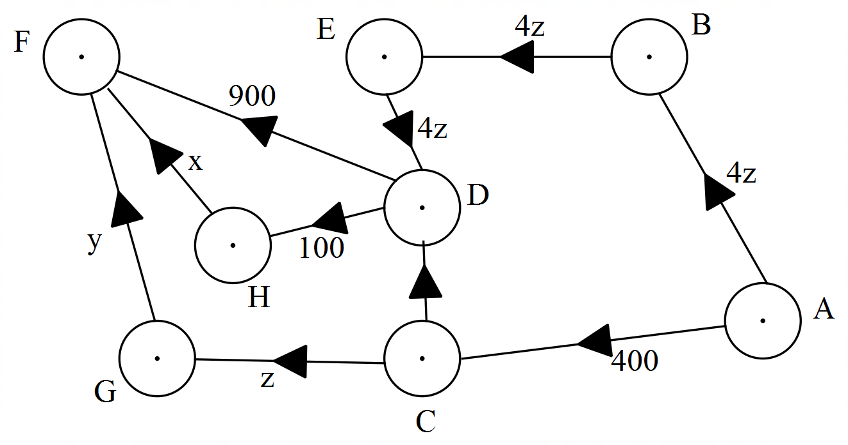

y

a) State the source and the sink.

Source: Sink:

b) Calculate x, y and z. Justify your answers.

c) Calculate the maximum flow.

|  |  |
| --- | --- |
|  | Student Name _______________________    **Eastern Goldfields College**  Mathematics Applications U3&4 2019  Test 6 1– Calculator Assumed Section |
| **Working Time: 40 minutes** | **Total Marks: 36 marks** |

**Question 4 [13 marks : 4, 2, 2, 3, 2]**

Charlie is planning his next holiday. Once he has decided that he wants to go on a holiday, the following things need to happen before he can go.

|  |  |  |  |
| --- | --- | --- | --- |
|  | **Activity** | **Preceding activity** | **Time to complete activity** |
| A | Pick a destination | None | 2 weeks |
| B | Get relevant vaccinations and health checks | Pick a destination | 3 days |
| C | Apply for passport | Pick a destination | 6 weeks |
| D | Start saving money | Pick a destination |  |
| E | Apply for a visa | Apply for a passport | 2 weeks |
| F | Travel insurance | Get relevant vaccinations and health checks | 3 days |
| G | Buy a plane ticket | Start saving | 1 day |
| H | Change currency | Buy a plane ticket | 1 day |
| I | Pack suitcase | Travel insurance, Apply for visa, Change currency | 2 days |
| J | Go to the airport and get on plane | Pack suitcase | 1 day |

a) Add the information from the table to the project network below, complete the project network and calculate the number of days Charlie allocated to saving money if it takes 100 days before he leaves for his holiday.

[Note: The diagram below is not drawn to scale]



b) What is the latest possible day he can start getting his health checks and vaccinations without delaying leaving for his holiday?

After deciding where is going to travel to Charlie begins collecting donations to take to an orphanage in a village he will visit.

c) How long can he collect donations for, without it delaying his departure?

d) If Charlie finishes all his relevant health checks on July 14th and uses all the float time allowed for this activity, what date does he go to the airport to get on the plane?

e) If there is a delay in the processing of his visa application and it takes an extra four weeks to process, how does this affect how long it takes before he can leave for his holiday?

**Question 5 [7 marks: 3, 2, 2]**

The network below shows the existing pipes in a garden reticulation scheme. The letters A to O represent the watering stations and the network must be connected to the main as shown. The owner wishes to replace the old rusty pipes with new pipes so that the water may flow more efficiently.

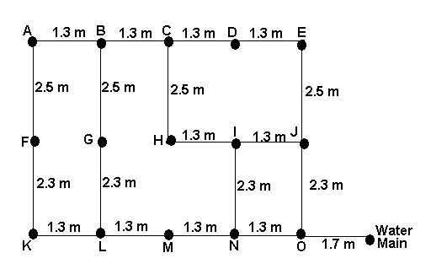

a) What is the minimum amount of pipe that needs to be replaced so that each of the stations ***(A to O)*** is connected by new pipe to the water main. *(ie. Find the minimum spanning tree of the network)*.

b) The current layout has obvious inefficiencies. Using the measurements from above design a completely new layout that would allow the least amount of pipe to be used in the network. Show this on the network below.

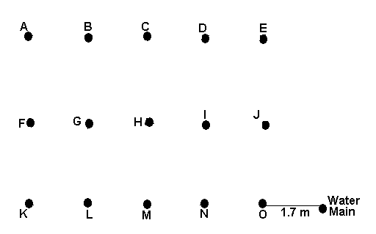

c) Given that the new pipe cost $25 per metre to install, how much money would have been saved using your solution to part (b) instead of part (a).

**Question 6 [10 marks: 5, 2, 3]**

The network below shows the available paths to transport raw product from mine M to port P. The number on each arc is the maximum weight of raw product that can be moved along it, in hundreds of tonnes per hour.

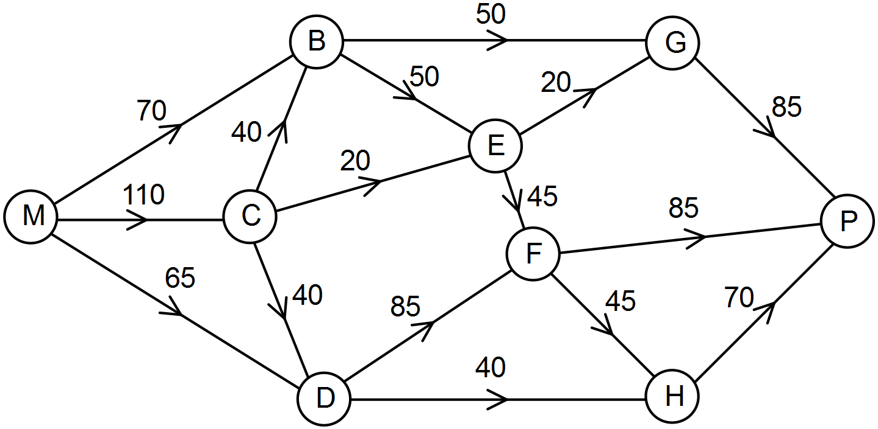

1. Determine the maximum weight of raw product that can be transported in one hour from the mine M to the port P. Show systematic working.
2. Show maximum flow equals minimum cut



1. The mine transport manager has funds to increase the capacity of arc CB or arc CD by up to 3 000 tonnes per hour. Determine which, if either, would be the best to choose and calculate the new maximum weight of raw product that can be transported in one hour from the mine M to the port P. Justify your answer.

**Question 7 [6 marks]**

The following table displays the delivery costs for companies A, B, C and D to complete four deliveries.

|  |  |  |  |  |
| --- | --- | --- | --- | --- |
|  | **Delivery Costs** | | | |
| **Company** | 1 | 2 | 3 | 4 |
| **A** | 100 | 220 | 350 | 110 |
| **B** | 90 | 200 | 300 | 100 |
| **C** | 110 | 190 | 360 | 150 |
| **D** | 150 | 140 | 310 | 120 |

Show how the Hungarian Algorithm can be used to find the most cost effective way of assigning the deliveries. Indicate the allocation on the original table and state the total cost of the four deliveries.

(Blank tables have been provided to assist you)

|  |  |  |  |  |
| --- | --- | --- | --- | --- |
|  | **Delivery Costs** | | | |
| **Company** | 1 | 2 | 3 | 4 |
| **A** |  |  |  |  |
| **B** |  |  |  |  |
| **C** |  |  |  |  |
| **D** |  |  |  |  |

|  |  |  |  |  |
| --- | --- | --- | --- | --- |
|  | **Delivery Costs** | | | |
| **Company** | 1 | 2 | 3 | 4 |
| **A** |  |  |  |  |
| **B** |  |  |  |  |
| **C** |  |  |  |  |
| **D** |  |  |  |  |

|  |  |  |  |  |
| --- | --- | --- | --- | --- |
|  | **Delivery Costs** | | | |
| **Company** | 1 | 2 | 3 | 4 |
| **A** |  |  |  |  |
| **B** |  |  |  |  |
| **C** |  |  |  |  |
| **D** |  |  |  |  |

**END OF TEST**